Chapter 8: Human wellbeing

Chapter overview
This chapter examines what we mean by the term ‘development’, how we use data to measure development and how and why development varies between places. A variety of geographic sources are used, including graphs, choropleth maps, photographs and cartoons. Students will be asked to interpret sources and to produce their own graphs, maps and diagrams. Access to ICT, including specific programs and websites, will be useful.
The chapter also explores the numerous (and interrelated) factors that contribute to differing levels of human wellbeing in a global context. Focusing on key human needs such as access to clean water, sanitation and shelter, and child exploitation, students develop a greater understanding of the influence of such factors on other facets of human wellbeing, and the specific challenges that face those in the developing world.

Syllabus links
Knowledge and understanding | Humanities and Social Sciences skills\ | General capabilities
Geographies of human wellbeing  The different ways of measuring and mapping human wellbeing and development, and how these can be applied to measure differences between places  The reasons for spatial variations between countries in selected indicators of human wellbeing  The issues affecting the development of places and their impact on human wellbeing, drawing on a study from a developing country or region in Africa, South America or the Pacific Islands  The role of international and national government and non-government organisations’ initiatives in improving human wellbeing in Australia and other countries | Questioning and researching  Identify current personal knowledge, gaps, misconceptions, currency of information, personal perspective and possible perspectives of others  Construct, select and evaluate a range of questions and hypotheses involving cause and effect, patterns and trends, and different perspectives  Use a range of methods to collect, select, record and organise relevant and reliable information and/or data from multiple sources that reflects the type of analysis of information that is needed (e.g. questionnaires, surveys, emails, discussion lists, tables, field sketches, annotated diagrams), with and without the use of digital and spatial technologies  Use appropriate ethical protocols, including specific formats for acknowledging other people’s information and understand that these formats vary between organisations  Analysing  Analyse information and/or data in different formats (e.g. to explain cause and effect relationships, comparisons, categories and subcategories, change over time)  Analyse the ‘big picture’ (e.g. put information and/or data into different contexts, reconstruct information by identifying new relationships, identify missing viewpoints or gaps in knowledge)  Apply subject-specific skills and concepts in familiar, new and hypothetical situations  Evaluating  Critically evaluate information and/or data and ideas from a range of sources to make generalisations and inferences; propose explanations for patterns, trends, relationships and anomalies; predict outcomes  Communicating and reflecting  Select a range of appropriate formats based on their effectiveness to suit audience and purpose, using relevant digital technologies as appropriate  Develop texts, particularly explanations and discussions, using evidence from a range of sources to support conclusions and/or arguments  Compare evidence to substantiate judgements (e.g. use information and/or data from different places or times; use tables, graphs, models, theories) | Critical and creative thinking  Ethical understanding  Numeracy  Personal and social capability  Intercultural understanding

Key concepts/terms
developed country—a rich, industrialised country of the world
developing country—a poor or middle-income country often dependent on subsistence farming.
development—a process of change that improves the quality of life of a community
human wellbeing— people’s quality of life, taking into account the extent to which an individual, family, or larger social grouping can be characterised as being healthy, happy and prosperous.
sanitation—the infrastructure related to the collection and disposal of human waste

Getting started

Using the image
The chapter opening image shows an Indian girl searching through garbage at a landfill site in New Delhi, India.
Students research what life is like in the slums of New Delhi. They can use qualitative or quantitative data. They should organise their findings about the conditions for slum dwellers under the headings ‘Social conditions’, ‘Environmental conditions’ and ‘Economic conditions’.

Pre-quiz
Students respond to the following questions.
1 Name five countries that you think of as developed and five that you think of as developing. Are there any countries that are hard to classify?
Student answers will vary.
2 Provide a definition for ‘poverty’.
A term used to define an individual or group of people who lack the essential resources and services to enjoy a minimum standard of health and wellbeing
3 What is the difference between absolute and relative poverty?
Absolute poverty is where people don’t have the basic necessities to survive. Relative poverty is where there are people who are poorer than others, but they have access to resources needed to survive.
4 What impact does a growing world population have on the environment?
Answers could include the pressure on resources, land degradation, pollution and habitat loss.
5 What data could you use to measure the development of a country?
Students could mention GDP, HDI, life expectancy, infant mortality, and literacy.
6 Poverty exists only in developing countries. True or false?
False. While the phrase ‘developing countries’ tends to refer to countries that experience lower levels of economic growth and security, people can live in poverty in both developed and developing countries.
7 Poverty is always caused by low levels of income. True or false?
False. According to the World Bank, while many who are living in poverty exist on far less money than the general population, poverty can also be experienced through poorly equipped infrastructure, such as roads; limited or poor access to health and education; limited access to electricity; and limited access to safe water.
8 You can only experience poverty if you are homeless. True or false?
False. Living in a home does not exclude people from being in a state of poverty.
9 Slavery does not exist anymore. True or false?
False. Slavery unfortunately continues to exist in contemporary society. Slavery can entail the coercion of people to work under conditions they would not agree to, working for little to no pay, and in many circumstances, working under the threat of violence.
10 People who live in poverty do not have access to new technologies, such as mobile phones, iPods and computers. True or false?
False. People can live in poverty while still owning technology such as mobile phones, iPods and computers.

Images of wellbeing
The aim of the task is for students to gain an understanding of the interrelated nature of the factors that contribute to human wellbeing, and how challenges to different aspects of wellbeing can affect other aspects. Provide students with a range of images representing different aspects of wellbeing in both developed and developing circumstances, for example scenes depicting:
- access to water
- education, for example participation in education
- technology
- healthcare
- pregnancy and children
- income
- different forms of employment
- infrastructure, such as roads, buildings, parks, sewerage and water systems.
Students place these images on a sheet of A3 paper and annotate each image with the most appropriate of the following factors: ‘social’, ‘historic’, ‘economic’, ‘environmental’, ‘political’, ‘technological’ or ‘cultural’. Students link the various aspects of wellbeing to each other, using arrows and annotations explaining the relationship between different images.

8.1 Development and human wellbeing

Learning strategies

Different shoes
Students consider how this unit might have been different if written and delivered by one of the following people:
- one of the ‘rich kids of Instagram’
- the woman or one of the children in the photograph in Source 8.1.2.

Music about poverty
Students research a song that has something to say about development, poverty or inequality. After choosing a song, they explain how the song links to the topic and what the songwriter has to say about poverty or development. Many songs and videos can be found on YouTube. The best song choices can be played at the beginning of subsequent lessons as a starter activity. Lyrics and videos may need to be vetted for appropriate content.

Analysing a photograph
Students study the photograph in Source 8.1.2 and brainstorm questions for the people in the photograph. They then share their questions with other students and see if anyone else is able to suggest responses for their questions.
Encourage students to base their questions on geographical concepts such as the social, economic and environmental (SEE) conditions shown in the photograph.
Questions they might ask are:
- Do the children go to school? (social)
- How much money does the family have for food each day or week? (economic)
- Where in the world was this photograph taken? (environmental).

Helpful hints

Vocabulary
The terms ‘First World’ and ‘Third World’ have largely gone out of fashion and are rarely used today. These terms were widely used after the World War II to describe capitalist, democratic countries, known as the First World, and communist countries, which made up the Second World. The Third World was everywhere else. Over time, these terms began to be associated with levels of development. Today, many of those communist countries are no longer communist and many countries that were once considered ‘Third World’ have experienced rapid industrialisation and economic growth, such as the BRICS—Brazil, Russia, India, China and South Africa.

Activity answers

Remembering and understanding
1 The term ‘human wellbeing’ refers to people’s quality of life. It takes into account the extent to which an individual, family, or larger social group can be characterised as being healthy, happy and prosperous.
2 ‘Development’ is a contested term. How it is defined depends on the beliefs people hold—their perspective or view of the world. It can be defined as simply the outcome of economic growth or it can be understood in terms of a dynamic, socio-economic process, the aim of which is a sustained improvement in people’s quality of life (or wellbeing).
3 The term ‘developed countries’ has traditionally referred to the wealthier countries with higher standards of living, such as countries of Western Europe, Canada, the United States, Japan, Australia and New Zealand. The term ‘developing countries’ referred to those countries still undergoing industrialisation and with lower Asia and Africa. This distinction in becoming harder to make as ‘developing countries’ become increasingly ‘developed’. More commonly used terms now are ‘more developed’, ‘less developed’ and ‘least developed’.

Applying and analysing
4
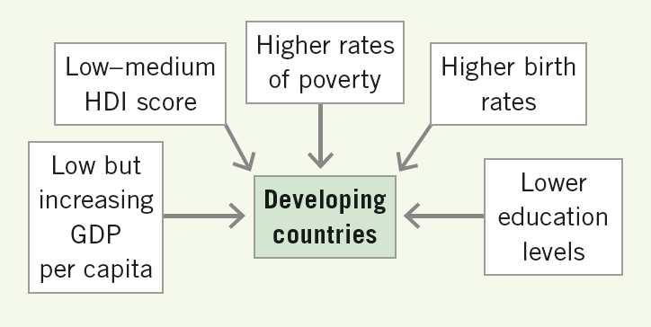
5 The world’s least developed countries are primarily located in equatorial and eastern Africa, and Asia.

8.2 Measuring and mapping human wellbeing

Learning strategies

Economic and social development
An economic indicator of development is a measure of a country’s economy and wealth; a human or social indicator of development is a measure of development based on the health, welfare and education of the people in a country. Students sort the following quantitative development indicators into social and economic categories:
- gross national product (economic)
- percentage employed in primary industries (economic)
- life expectancy (social)
- unemployment (economic)
- Human Development Index (social and economic)
- infant mortality (social)
- fertility rate (social)
- gross domestic product (economic)
- gross national income (economic)
- percentage of population living in rural areas (economic)
- literacy rate (social).

Creating a choropleth map
In a choropleth map, like the map in Source 8.2.4, differences in colour or shading indicate different values for a given area. In this case, students are going to use an online or paper copy of a blank outline map of the world to contrast levels of development using an indicator of their choice. They follow the steps below.
1 Students select the development indicator they would like to map, for example life expectancy. They then collect data on the average life expectancy for each country they are mapping and create a table of data. This data can be found online; some atlases have a table of statistics for each country that includes a variety of development indicators.
2 Students decide how the data will be divided and grouped—three to five categories is usually ideal. Each category is represented on the map by a different colour or shade. The most effective maps have a logical sequence of colour or shades, for instance from light to dark or hot to cold colours. The data table then needs to be manipulated so that countries are grouped from highest to lowest for the chosen development indicator.
3 Using a blank outline map, which can be found online and printed or cut and pasted into a paint application, students begin to colour-code each country. If they are using Microsoft Paint, they can use the bucket icon to colour each country. More detailed instructions for creating choropleth maps are available online.
4 Students complete the map by ensuring that they have included all elements of BOLTSS (border, orientation, legend, title, scale and source).
5 Students describe the data and explain patterns and anomalies.

Inequality in Australia
While Australia as a whole enjoys some of the highest levels of human wellbeing in the world, Aboriginal and Torres Strait Islander people often experience poorer wellbeing. Students plan and conduct an investigation into this topic and produce a written report. Below is a suggested format.
1 Students devise a suitable research question to drive the investigation.
2 Students gather qualitative and quantitative data to compare the two groups. They evaluate sources for accuracy, bias, reliability and usefulness.
3 Students analyse the data by looking for patterns, anomalies, trends, and relationships; propose explanations; and make generalisations based on the data.
4 Students draw conclusions based on the analysis of data and predict outcomes. They link back to the research question generated in step 1.

Helpful hints

Asia’s rise: how and when?
In 2009, Hans Rosling made a short presentation called ‘Asia’s Rise: How and When’, which predicted when per capita income in China and India would match that of the UK, USA and Japan. A link to the video can be found online. The presentation can be used as a stimulus for discussion about India and China’s changing fortunes. As well as interactive graphs, the Gapminder website has links to videos that explain how the graphs can be used to interpret information about development. The Gapminder website is a fascinating tool for individual exploration or for a teacher-led workshop.

Activity answers

Remembering and understanding
1 The qualitative indicators of human wellbeing are those aspects of our standard of living that are difficult to measure, such as political freedoms, social opportunities and personal security. Quantitative indicators are those that are objective, measurable and typically take the form of data or an index score, such as GNP.
2 When qualitative and quantitative indicators of human wellbeing are mapped, spatial patterns emerge. These patterns, the reasons for them and the ways in which they change over time are of interest to geographers.
3 Quantitative indicators include life expectancy, education levels and income. Composite quantitative indicators such as the Human Development Index can also be used to measure wellbeing. Life expectancy reflects exposure to disease and access to medical treatment, education reflects access to schooling for either gender, and income per person reflects the overall wealth of a country. The HDI draws together a number of indicators to reflect the overall development level of a country.
4 A composite measure, such as the HDI, is the measure that results when various indicators are compiled, using an algorithm, into a single score.
5 GNP has been criticised for failing to accurately measure economic activity, especially in developing countries, where much of the activity takes place outside the formal economy. In addition it provides little information on the distribution of wealth and poverty levels.
6 The IHDI is an attempt to measure of the level of human wellbeing and inequality.
7 Qualitative measures are difficult to determine. Human wellbeing can be measured using qualitative (subjective) measures of how people perceive the quality of the life they experience.

Applying and analysing
8 a ‘High-income’ countries are located in Western Europe, North America and select countries in the Asia Pacific and the Middle East.
b ‘Low-income’ countries are typically located in Africa, Asia and South America.
9 Overwhelmingly, there is a correlation between GNP per capita and a country’s IHDI score.
10 a Israel; plus the following countries do not feature in the IHDI column of the table: USA, New Zealand, Singapore, Hong Kong, Lichtenstein, South Korea
b Sweden, Iceland, Belgium

Evaluating and creating
11 Student answers will vary based on what the most up-to-date statistics were at the time of their research.

8.3 Changes in spatial wellbeing

Learning strategies

The world in 2020
Students create a PMI chart (a table with the headings ‘Plus’, ‘Minus’ and ‘Interesting’) to explore the consequences of economic growth in emerging economies such as the BRICS (Brazil, Russia, India, China and South Africa). They consider the opportunities and challenges for society, the environment and global and national economies.

Using Gini to identify inequality
Show students a choropleth map of the Gini coefficient of countries around the world and ask them to complete the following tasks.
1 Describe patterns of inequality shown in the map. Look for trends, anomalies and relationships.
2 Research two countries and explain the factors that have contributed to their Gini coefficient.
3 Explain how people and societies are affected by inequality.
4 Predict how the map will change in 100 years’ time. Do you think there will be more or less inequality? Why?

Helpful hints

The Gini coefficient
The Gini coefficient is a measure of income inequality within countries. A country with an index of 0 would have complete equality and everybody would have the same wealth or income, whereas a country with an index of 1.00 would be completely unequal, with one person holding all of the wealth.

Activity answers

Remembering and understanding
1 Wealth and wellbeing change over time. India and China have enjoyed relatively higher levels of wellbeing in the past and are likely to again. Poverty reduction in the developing world is exceeding expectations.
2 Marco Polo brought back to Europe porcelain, paper, paper currency and the compass.
3 It is likely there will be a major shift in the global balance of economic power compared with today. Emerging economies will grow in importance and China will overtake the United States of America in terms of GDP. It is likely that this shift in economic power will affect human wellbeing, with the wellbeing of people in countries such as China improving.
4 As wellbeing in populous countries such as China, India and Indonesia improves, these countries are likely to exert political influence. This risks bringing them into conflict with countries such as the USA, UK and Australia.

Applying and analysing
5 Small changes can be observed when the graph is rearranged; the United States is still number 1, with the greatest disparity, while Denmark remains at the bottom of the list with least disparity. Australia jumps to number 3 from number 6.
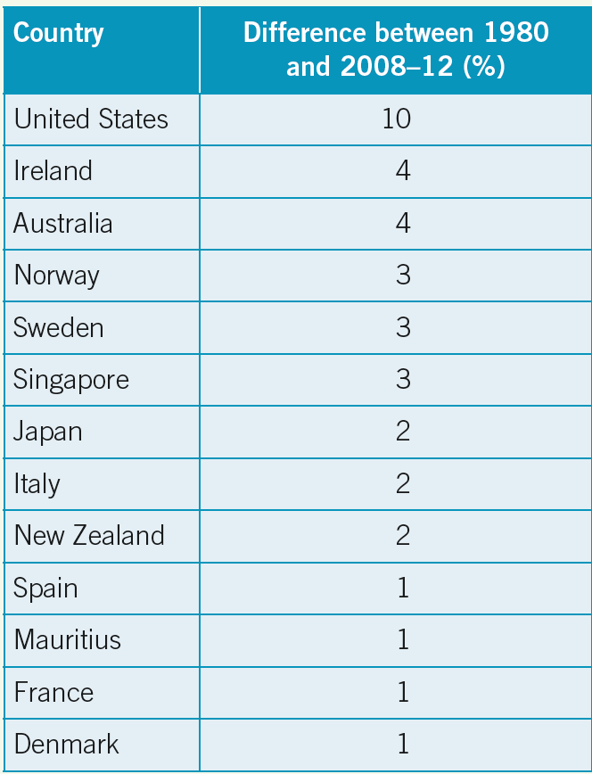

Evaluating and creating
6 Student answers will vary.

8.4 Causes of spatial inequality: External factors

Learning strategies

Ignite presentation
An Ignite talk uses the format of twenty slides that auto-advance after 15 seconds. This means each presentation lasts exactly 5 minutes—the motto of Ignite is ‘enlighten us, but make it quick’. Ignite talks can be found on the internet.
Allocate topics from the following list to pairs of students to research for an Ignite talk:
- fair trade
- microcredit
- Kiva
- chocolate and child slavery
- the positive and negative impacts of aid
- World Bank
- IMF
- types of aid
- sweatshops
- TNCs
- colonialism.

Evaluating aid
Explain to students that one side of the classroom represents ‘strongly agree’ and the opposite side represents ‘strongly disagree’. The middle of the classroom is a neutral space.
Students line up and move across the room according to their opinion on the following statements.
- We should offer aid to our neighbours after disasters.
- We should offer aid to all countries after disasters.
- We should only provide disaster aid to countries who have offered us aid after disasters.
- Sometimes aid does not go to those who need it most due to corruption.
- Money is the best type of aid to offer.
- Food or resources are the best types of aid to offer.
- Development projects are the best type of aid projects to fund.
- Aid should only be offered in an emergency.
- Aid encourages less developed countries to become reliant on developed countries.
- Only sustainable aid projects that do not damage the environment should be supported.
- Donor countries should be able to decide how aid is distributed in a receiving country.
- Australia should cut back on aid to other countries and spend the money on Australians who need help instead.
- I have donated time, money or goods to a charity or NGO for an overseas aid project.
- It is better to give aid for large-scale projects rather than lots of small projects.
- It is better to give small amounts of aid directly to the people who need it so that they can decide how to help themselves.
- Instead of giving aid, donor countries should write off all of the debt that they are owed by less developed countries.
- It was wrong for the Australian Government to cut the aid budget to other countries in the 2014 budget.

Using Gapminder to investigate the BRICS
Using the Gapminder website, students create an interactive graph to compare the development of the BRICS (Brazil, Russia, India, China and South Africa), which have fast-growing economies. When the graph opens, the default setting is life expectancy on the Y-axis and income per capita on the X-axis, which is a good place to start. To the right of the graph students are able to select the countries they wish to compare. Students select the BRICS and Australia for a comparison and answer the following questions.
1 What does the size of the dot tell you about a country?
The size of the population
2 Identify when life expectancy begins to rise in Australia and the BRICS.
Life expectancy begins to rise in:
- Australia in the early 1900s
- Brazil in the 1970s
- Russia in the 1950s
- India in the 1960s
- China in the 1960s
- South Africa in the 1970s.
3 Pick one of the BRICS and describe how it has developed over time.
Student answers will vary.
4 Describe the relationship between income per person and life expectancy.
The general relationship is the greater income per person, the greater the life expectancy.
5 Predict what the graph might look like in 2020.
Student answers will vary.
6 Using different development indicators, create a new graph to compare the relationship between economic and human development. Explain your choice of development indicators and what the new graph indicates about the development of the BRICS.

Activity answers

Remembering and understanding
1 Prior to independence, the colonies were used as markets for finished products and other surpluses produced in the industrialised countries. At the same time, the colonies supplied raw materials and foodstuffs needed by the colonial power. Restrictions were often placed on colonies so that they could not produce goods that were already produced by the colonial power, or to trade freely with countries other than the colonial power.
2 Since independence, established trade relationships have continued, with the wealthy countries, long after the demise of colonialism, continuing to dominate international trading relationships.
3 Developing countries are usually at a disadvantage in world trade: the value of their imports often exceeds the income earned from their exports. As a result, they are likely to incur a debt rather than earn a surplus through trade.
4 Developing countries are attractive to TNCs because of their abundant supply of cheap labour, often accompanied by less stringent industrial relations laws regarding wages, hours of employment and working conditions.
5 Bilateral aid is aid supplied between governments. International institutions such as the World Bank give multilateral aid. Non-governmental aid is distributed by non-government organisations (NGOs), which receive most their income from donations by the general public.

Applying and analysing
6 Student answers will vary.
7 a The characters carrying baskets represent the UK (top hat and red tails) and the USA (top hat in colours of US flag). These characters represent colonial powers and developed countries.
b The goal that they are attempting to achieve is so-called ‘civilisation’. Barriers to reaching this goal include ignorance, vice, brutality and slavery.
c The image is drawn from a developed, wealthy country perspective and is aimed at an audience in those countries.
d Today such an image would not be considered appropriate and would be labelled racist. The image implies that those from developed countries are unable to reach the goal of a ‘civilised’ society without the help and hard work of developed countries. The illustrator implies that it is not imperial powers who are ignorant but the people in developing countries.
8 The major markets for timber and wood products from the Congo basin are China, France and Italy. This market has been exploited due to a variety of reasons: over-exploitation of forests in destination countries, protection of forests in destination countries, use of wood products in industry, cheap wood from the Democratic Republic of the Congo, less restrictions of wood products in the Congo.
9 a UK, USA, China, India, UAE
b Africa, South America and the Pacific
c Investor countries predominantly come from the developed and wealthier countries of North America, Europe, the Middle East and Asia, while target countries are located the less developed and poorer countries in South America, Africa and the Pacific.

Evaluating and creating
10 Student answers will vary.

8.5 Causes of spatial inequality: Internal factors

Learning strategies

Starter activity
Before students begin reading the text from Unit 8.5 they consider the following question: Why are some countries more developed than others?
After a few minutes they share their ideas with a neighbour. After everyone has had a chance to talk about the question with a partner they share their responses with the wider group. A scribe writes up the ideas and these notes are reviewed at the end of the lesson to evaluate how their understanding has progressed. Students have already encountered external factors influencing development in Unit 8.4 and this understanding should be present in their initial ideas.

Political cartoons
A political cartoon conveys a message about an issue, often one that is currently in the news. Students find a political cartoon that has a message about a development issue. They can search using Google images. The cartoons and their explanations can be printed and displayed or presented at the beginning of the next lesson. Alternatively, students create their own political cartoon with a message about development.

Activity answers

Remembering and understanding
1 A country’s ability to provide for the needs of its people is affected by the growth rate of its population. If the rate of population growth exceeds the rate of economic growth, each person’s share of the ‘economic pie’ becomes smaller, and the government is less able to provide adequate facilities for its people.
2 Africa’s projected population growth is a consequence of the high fertility rate in Africa, which is currently 4.8 children per woman.
3 A resource base refers to the ability of a country to generate wealth from the exploitation of its natural resources. It also refers to the ability of a country’s biophysical environment to provide a range of agricultural activities that allow a country to become self-sufficient in food production. Surpluses can be traded internationally to generate capital for investment in other areas. This use and exploitation of the resource base has an impact on human wellbeing—food can sustain people and surpluses can benefit communities. If the environment is incapable of supporting large-scale food production, a country may be forced to rely on costly imports to meet the needs of its people. An exception to this is Japan, which has improved wellbeing as a result of the export of manufactured items made from imported raw materials.
4 Political instability can cause war and civil unrest, weak political institutions and corruption. Money that should be spent on social infrastructure to increase human wellbeing is instead channelled to other areas, such as the military, or is lost through corruption.
5 In developing countries, people are often engaged in practices at a local level that can cause environmental degradation. This is frequently the result of the struggle for survival. Population growth and increased use of land for commercial agriculture can force the expansion of subsistence agricultural activities into more marginal areas, resulting in land clearing and loss of soil fertility. Crops in these areas are more likely to fail, perpetuating the cycle of poverty. At the national level, the need to repay foreign debt means that governments encourage the extension of cash cropping, mining and forestry, frequently at the expense of the environment.
6 The cause of desertification in the Sahel region is the overuse of land and destruction of ground cover. As the boundaries of the desert are gradually being extended, arable land is subject to increased pressure. The land becomes further degraded and less fertile in an ongoing cycle.

Applying and analysing
7 The cartoonist is attempting to convey the message that Africa’s prospects of advancing human wellbeing continues to be held back or ‘weighed down’ by the debt burden, as well as AIDS poverty, hunger and corruption.
8 a Africa = 108 per cent, Sub-Saharan Africa = 144 per cent, Asia = 20 per cent
b The population of Africa is increasing at a faster rate than the population of Asia, although Asia has a larger population. The population in Sub‑Saharan Africa is increasing at a faster rate to that of ‘All Africa’.
c North America and Europe will have no net increase in population.
9 Student answers will vary.

8.6 Human wellbeing: The issues

Learning strategies

Terms of development
Students match key terms to their definitions, as an introduction to the concepts explored in this unit. They could use a table such as the following.
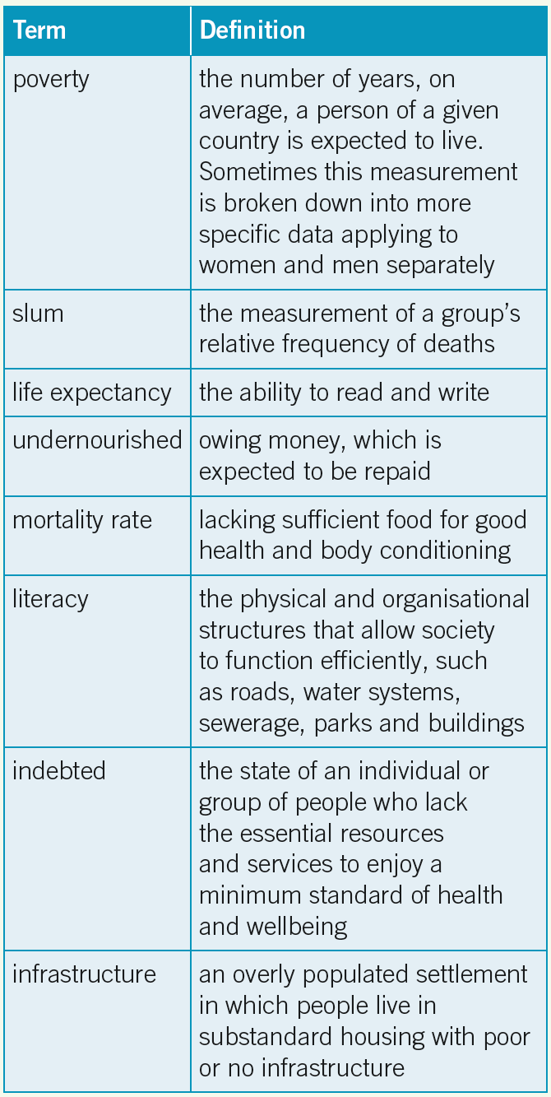
Answers:
- poverty: the state of an individual or group of people who lack the essential resources and services to enjoy a minimum standard of health and wellbeing
- slum: an overly populated settlement in which people live in substandard housing with poor or no infrastructure
- life expectancy: the number of years, on average, a person of a given country is expected to live. Sometimes this measurement is broken down into more specific data applying to women and men separately
- undernourished: lacking sufficient food for good health and body conditioning mortality rate: the measurement of a group’s relative frequency of deaths
- literacy: the ability to read and write indebted: owing money, which is expected to be repaid
- infrastructure: the physical and organisational structures that allow society to function efficiently, such as roads, water systems, sewerage, parks and buildings

Visualising development
An annotated visual display (AVD) allows students to articulate their understanding of a particular concept or theme using predominantly visual sources such as photographs, tables, graphs, maps and other forms of visual information. Through this task, students can demonstrate their understanding of the various factors that contribute to human wellbeing by creating an AVD (hand-constructed or using ICT) that provides visual examples that indicate higher and lower levels of development. Students present visual examples that draw on each subheading in Unit 8.6. They demonstrate their ability to make connections between different concepts by creating a mind map with the images, and writing brief annotations explaining connections, causes and effects.

Activity answers

Remembering and understanding
1 Worldwide, 896 million people live in extreme poverty. Sub-Saharan Africa and southern Asia account for about 40 per cent of the world’s population living in extreme poverty.
2 Lack of water and sanitation impacts negatively on human wellbeing, as diseases originating from contaminated water supplies and inadequate sanitation disproportionately affect the poor. Many diseases deepen poverty and make living conditions worse.
There is also considerable time and energy spent obtaining water supplies and carrying heavy loads of water over long distances, as people are excluded from the health and economic benefits of piped drinking water at home, particularly in rural areas.
3 Worldwide, one-third of the global workforce is engaged in primary production (agriculture).

Applying and analysing
4 In 2015, 25 per cent of the world’s population was classified as undernourished. This would equate with a figure of around 1.8 billion people. The consequences of poor nutrition are immense and include poorer health, greater susceptibility to disease and low life expectancy.
5 Low income countries lack the funds to supply adequate electricity infrastructure. Those countries with poor infrastructure also have much lower levels of electricity consumption. Other factors that influence energy consumption include access to energy-consuming technology.
6
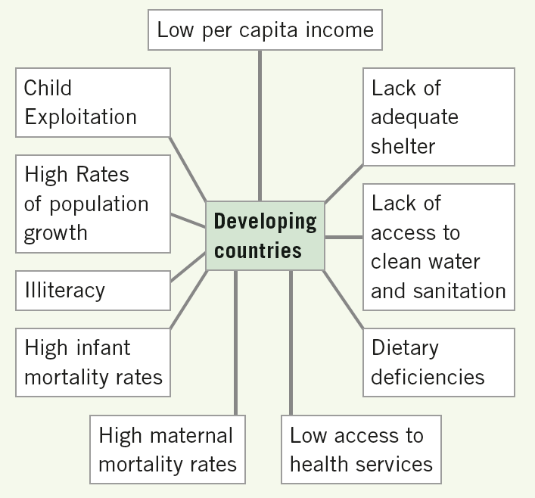
7 Improvements in human wellbeing since 1990 include:
- proportion of people living on less than $1.90 a day falling from 37 per cent in 1990 to 12.7 per cent in 2013
- between 1990 and 2015, 2.1 billion people gaining access to a flush toilet or other improved sanitation facility
- global maternal mortality ratio declining by 47 per cent
- initiatives to ‘forgive’ debt since the early 1990s reducing the debt burden of many countries.
8 a i The highest life expectancy rates occur in Western Europe, Canada, Chile, Australia, Japan and South Korea, while the lowest life expectancy rates are found in Africa.
ii The lowest infant mortality rates are found in the United States of America, Canada, Chile, Western Europe, Japan, South Korea, Malaysia, New Zealand and Australia, while the highest infant mortality rates are found in Africa and parts of Asia.
b There is a strong spatial correlation between low life expectancy and high infant mortality rates, and vice versa.
9 The trend in agricultural employment is declining in all regions of the world.

8.7 NGOs: Making a difference

Learning strategies

Do you know the NGO?
Find images of the logos of NGOs. NGOs could include Amnesty International, the Red Cross, Médecins Sans Frontières, Oxfam, World Vision, WaterAid, Fred Hollows Foundation, Greenpeace, WWF, Project Futures and Save the Children. Once you have collected the logos, create a quiz (print or multimedia). Show students (in pairs or small groups) the logos and see how many NGOs the students know.
Alternatively, create a quiz with the logos and the main missions of the NGOs. Students link each NGO logo with its mission statement.

The work of Amnesty International
A video can be accessed through the ‘About Us’ section of the Amnesty International Australia website. Students watch the short clip on Amnesty International, and take notes on important facts as they watch (the clip may have to be paused to allow students to do this effectively). In small groups, students then decide on the five most important facts that have been presented to them, along with a brief justification for their decision. These can be shared with the class.

Activity answers

Remembering and understanding
1 A non-governmental organisation (NGO) is any non-profit, voluntary citizens’ group organised on a local, national or international scale. NGOs work to address a range of challenges in developing countries, such as water and sanitation, healthcare, worker exploitation, children’s wellbeing, human rights and development.
2 Many NGOs are able to reach the most marginalised and vulnerable people. They are able to work in areas that are difficult to access due to armed conflict or civil unrest, because they do not take sides in conflicts between warring factions. Many also have expertise in working in emergency situations.
3 Amnesty International is an organisation that aims to create a world in which every person enjoys all the human rights enshrined in the Universal Declaration of Human Rights and other international human rights instruments.
4 Amnesty International:
- works to secure the release of prisoners of conscience
- works for the fair and prompt trials of all political prisoners
- opposes the death penalty, torture and other cruel, inhumane or degrading treatment or punishment.

Applying and analysing
5 Student answers will vary.
6 Student answers will vary.

Evaluating and creating
7 Student answers will vary.
8 Student answers will vary.

8.8 Access to water and sanitation

Learning strategies

Comparing statistical data
The World Bank provides a range of statistical data concerning different factors affecting human wellbeing, such as life expectancy, GNI, maternal mortality rates, primary completion rate, and so on. Allocate a set of data to students, from which they produce a choropleth map illustrating their specific data. Students then overlay this data with maps showing access to water, and draw out similarities and differences in the two sets of data. Ask students:
- What is the distribution of your chosen data set?
- On what scale do the general trends of your data tend to operate (e.g. local, national, regional, global)
- What is the spatial association between your chosen data and access to improved drinking water (strong, moderate, weak, OR high, medium, low)?
- What factors may contribute to this relationship?
As an extension, students could compare their data set to older sets of data, and draw out a number of examples of countries for which data has changed significantly. They could use their wider knowledge of the issue to hypothesise about what may have contributed to this change.

The most important …
The seventh Millennium Development Goal, ‘ensure environmental sustainability’, includes the aim to promote improved access to sanitation. A key campaign implemented through the MDGs is the ‘End Open Defecation’ campaign, for which there is a website. Students access this website, as well as the websites of some of the key partner organisations, and compile a list of the ten most important facts that they believe are relevant to this particular campaign. This could be used as a platform for further student research, along with the exploration of the management strategies involved in eradicating this issue. Apart from the UN Millennium Development Goals website, other useful websites are:
- Open Defecation
- Human Rights Watch
- Water and Sanitation Program—World Bank
- Sanitation and Water for All
- End Water Poverty
- WASH United
- Water Supply & Sanitation Collaborative Council.

Activity answers

Remembering and understanding
1 In the period 1990 to 2010, the percentage of people without sustainable access to safe drinking water and basic sanitation was halved.
2 An ‘improved water source’ can include piped water on premises (piped household water connection located inside the user’s dwelling, plot or yard) and other improved drinking water sources, such as public taps or standpipes, tube wells or boreholes, protected dug wells, protected springs and rainwater collection.
3 Carrying large amounts of water over long distances presents a significant physical burden. Women often carry water-filled containers on their heads, which creates physical demands on their bodies, especially the spine and neck. The countless hours spent fetching water can also lock women in a cycle of poverty, in which they cannot attend school or earn an income.
4 The benefits of providing villages with safe, convenient sources of cold water are many but include:
- increased school attendance, level of education and literacy rates, as girls no longer need to miss school to secure water for their families
- improved health for women and girls
- reduced child and maternal mortality as a result of access to safe water and improved hygiene during childbirth
- reduced physical injury, as women no longer need to lift and carry heavy loads of water
- reduced risk of rape and sexual assault, and increased safety, as women and girls do not have to go long distances to fetch water
- new opportunities for women’s employment as well as greater autonomy and independence.
5 Lack of sanitation infrastructure forces people to defecate in the open, in rivers or near areas where children play or food is prepared. It also forces people to dump raw sewage into open waterways. These actions increase the risk of disease transmission.
6 The impacts of untreated sewage on waterways are immense. For example, just one gram of faeces in untreated water may contain 10 million viruses, one million bacteria, 1000 parasite cysts and 100 worm eggs. The Ganges River in India has 1.1 million litres of raw sewage dumped into it every minute.
7 Improving sanitation infrastructure can have an immediate impact on public health. It can, for example, reduce diarrhoea death rates by up to a third. In addition to improvements to people’s health, the provision of sanitation has a number of important social benefits. The provision of sanitation in schools, for instance, encourages children to attend school, particularly girls. The liveability of neighbourhoods improves as the incidence of open defecation declines.
8 Strategies being used to meet the sanitation needs of people include providing the necessary infrastructure, education campaigns aimed at stopping the practice of open defecation, and the construction of communal toilet facilities.

Applying and analysing
9 Source 8.8.1 shows that access to piped-on-premises and improved sources of water has increased in the time frame shown. However, significant populations of people have access only to surface water or other unimproved sources. The data shows that people in urban areas have greater access to either piped-on-premises or improved water sources. In contrast, while improvements have been made, most rural people can hope for improved sources of water at best. Piped-on-premises safe water is largely unavailable.
10 Many African countries, Afghanistan, Cambodia, Laos and Papua New Guinea have the lowest levels of access to sanitation.
11 All regions, with the exception of Oceania (which has remained static), have made significant increases in the proportion of population with access to improved water sources. In additional, all areas have greatly reduced the proportion of the population using open defecation (with the exception of Oceania, whose reduction was only slight).

Evaluating and creating
12 Student answers will vary.

8.9 Access to shelter

Learning strategies

Debating the problem
Students explore issues of urban development by examining the following proposition: ‘The world ignores slums at its peril’. Students respond by:
- conducting a debate on the proposition, or
- writing a report responding to the proposition.
Students will find the following websites useful:
- The Mega-Cities Project
- UN Habitat
- Cities Alliance.

Megacities of the world
The purpose of this task is to give students a greater understanding of the needs of urban environments, and how significant urban developments can result in the slums. Students research the term ‘megacities’ (urban agglomerations with over 10 million citizens), and map the major megacities on a world map. Although in 1950 there were only two megacities—New York and Tokyo— the UN predicts that by 2025, twenty-nine of a total thirty-seven megacities will be in the developing world. Students:
- locate data about megacities
- develop a key to categorise different sizes of megacities
- illustrate their findings as a choropleth map, ensuring that BOLTSS are applied
- analyse the distribution of megacities across the globe and describe the general scale that these patterns occur within
- analyse the spatial association between developing countries and the presence of megacities
- provide at least one reason for why slums tend to occur in conjunction with megacities (they may need to conduct additional research for this question).

Slum management plan
Working in pairs, students develop an integrated urban management plan for one of the slums mentioned in the unit. The plan should include the following information:
- a map of the slum
- current facilities and infrastructure
- proposed facilities and infrastructure (included reasons why these facilities need to be built and a time frame)
- current and proposed community programs.
Students may draw on their previous study of liveability in earlier years.

Activity answers

Remembering and understanding
1 Shelter is a basic human need. Lack of shelter is frequently due to poverty and has a significant impact on wellbeing, as living conditions associated with poverty are unhealthy and cramped, and there is significant risk of disease.
2 The process of people moving from rural areas into large cities is known as urbanisation. Throughout the developing world, the rate of urbanisation has overwhelmed authorities. They have found it impossible to meet the demand for housing and even the most basic urban infrastructure, such as water and power supplies, sanitation and public transport, not to mention medical services and schools. Many people moving to these urban areas are poor and unable to find accommodation. They are forced to find shelter in squatter settlements or slums.
3 Squatter settlements are informal, often illegal settlements, built by poor people using material scavenged from the streets. A slum is a rundown established neighbourhood in which most people live in a state of poverty.
4 A range of strategies is used to address the growth of squatter settlements. These include slum removal, slum improvement initiatives, urban infrastructure upgrades and public housing construction.

Applying and analysing
5 Student answers will vary.
6 Student answers will vary.
7 Student answers will vary.
8 Southern Asia experienced the largest reduction in the proportion of urban population living in slums, while western Asia experienced the largest growth from 2000 to 2012.
9 Nigeria has the largest urban population. Sudan has the highest proportion of its population living in slums. South Africa has approximately 30 million urban dwellers.
10 Student answers will vary.

Evaluating and creating
11 Student answers will vary.

8.10 Child exploitation

Learning strategies

The business of exploitation
Many students may be unaware of recent international pressure on companies to ensure that they are not involved in child exploitation. Students imagine they are going shopping and want to ensure that what they buy has not been created using bonded or slave labour. They write ten questions to ask companies or businesses about their policies to ensure their products have been created without the use of bonded labourers or slaves. The following website may be helpful for developing questions: Made In A Free World.

A profile on exploitation
There are numerous incidents of child exploitation occurring globally. Students conduct a brief internet survey, and research in detail one of the twenty countries with the highest prevalence of child marriages.
Facts that students could search for are:
- the percentage of children married before the age of 18
- the factors that contribute to the prevalence of child marriage in this country
- strategies and solutions to reduce the prevalence of child marriage.
The following websites have useful information about education and child exploitation:
- UNESCO eAtlas
- Girls Not Brides
- Walk Free
- Made in a Free World
- International Center for Research on Women
- International Women’s Development Agency.

Child marriage: causes and effects
Students begin by mapping the data for the twenty countries with the highest prevalence of child marriage, as shown in Source 8.10.2. Students then research data on the following information and produce overlay maps of this data.
- percentages of children in/out of primary school education
- female literacy/ illiteracy levels
- maternal mortality rates.
Students then:
- describe any common patterns among the four maps—they can use the technique PQE (pattern, quantification, exception) to articulate their response
- write a short response, noting the factors (social, historic, economic, environmental, political, technological and/or cultural) that may have contributed to the above data.
The following websites are particularly useful for global statistics on education and child exploitation:
- UNESCO eAtlas
- Girls Not Brides
- Walk Free
- Made in a Free World.

Activity answers

Remembering and understanding
1 The consequences of child exploitation are increased risk of death, poor physical and mental health, homelessness and HIV/AIDS. Exploited children are unlikely to receive an education.
2 UNICEF estimates that 150 million children aged 5–14 years are engaged in child labour. The problem is worst in sub- Saharan Africa and South Asia.
3 Child trafficking involves the recruitment, abduction, transportation or receipt of children. Children are traded for the purpose of exploitation. Exploitation includes forcing children into prostitution, forced labour and begging, and using them for the harvesting of internal organs.
4 Many child marriages are linked to poverty, as girls’ parents often need the money raised to feed, clothe, educate and provide shelter for the rest of their family.
5 Slavery is the possession or control of people to deny freedom and exploit them for profit or sex, usually through violence, coercion or deception. The definition includes indentured servitude, forced marriage and the abduction of children to serve in wars.

Applying and analysing
6 Student answers will vary.
7 The parts of the world with the highest percentage of people enslaved are Central and Western Africa, Haiti and the Dominican Republic, India, Pakistan, Nepal and South-East Asia.

Evaluating and creating
8 Student answers will vary.
9 Student answers will vary.

